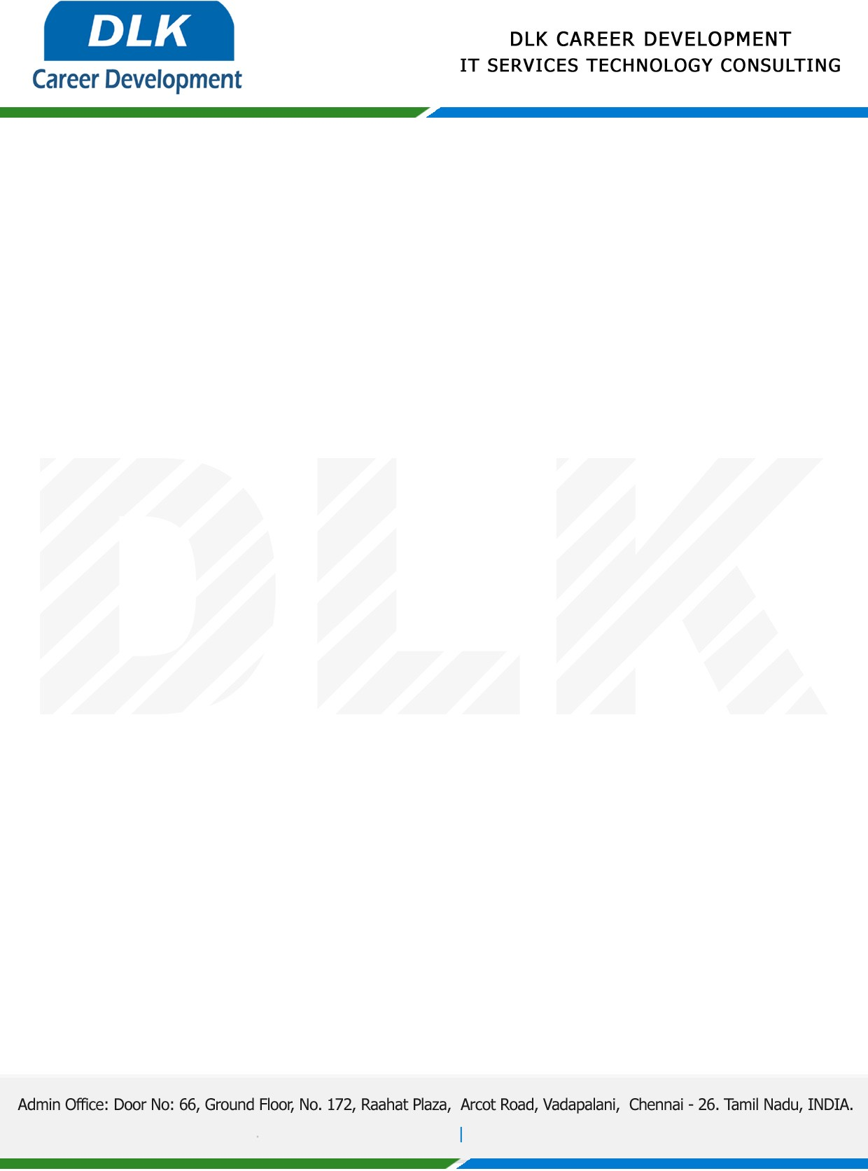

Date: 18 /May / 2023

**To**

Department of MCA (Computer Application),

Head of Department,

Dr.MGR Education and Research Institute, Chennai-600 095.

**Sub: Letter of Internship Acceptance**

This is to certify that **MR DEEPAN CHAKKARAVARTHY S (REG NO:** **S221960 )** first year student of has accepted the internship Work duration from **12th April 2023** to **19th May 2023** under the domain **“MACHINE LEARNING”.** During the internship, all information and data collected from you should be kept confidential.

We appreciate your interest in **DLK CAREER DEVELOPMENT**

